**Android lab: 02-03-2022**

**Q. Activity lifecycle**

MainActivity.java

package com.example.lifecycle;  
  
import androidx.appcompat.app.AppCompatActivity;  
  
import android.os.Bundle;  
import android.util.Log;  
  
public class MainActivity extends AppCompatActivity {  
  
 @Override  
 protected void onCreate(Bundle savedInstanceState) {  
 super.onCreate(savedInstanceState);  
 setContentView(R.layout.*activity_main*);  
 Log.*d*("lifecycle","onCreate Invoked");  
 }  
 @Override  
 protected void onStart() {  
 super.onStart();  
 Log.*d*("lifecycle","onStart Invoked");  
 }  
 @Override  
 protected void onResume() {  
 super.onResume();  
 Log.*d*("lifecycle","onResume Invoked");  
 }  
 @Override  
 protected void onPause() {  
 super.onPause();  
 Log.*d*("lifecycle","onPause Invoked");  
 }  
 @Override  
 protected void onStop() {  
 super.onStop();  
 Log.*d*("lifecycle","onStop Invoked");  
 }  
 @Override  
 protected void onDestroy() {  
 super.onDestroy();  
 Log.*d*("lifecycle","onDestroy Invoked");  
 }  
  
  
}

**Output**

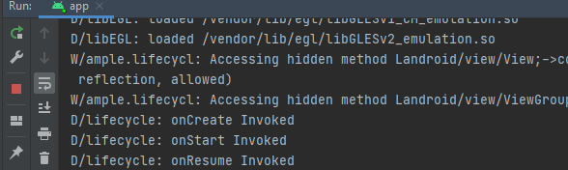

**Q. Exception Handling**

**activity_main.xml**

<?xml version="1.0" encoding="utf-8"?>  
<androidx.constraintlayout.widget.ConstraintLayout xmlns:android="http://schemas.android.com/apk/res/android"  
 xmlns:app="http://schemas.android.com/apk/res-auto"  
 xmlns:tools="http://schemas.android.com/tools"  
 android:layout_width="match_parent"  
 android:layout_height="match_parent"  
 tools:context=".MainActivity">  
  
  
 <ListView  
 android:layout_width="151dp"  
 android:layout_height="46dp"  
 app:layout_constraintBottom_toBottomOf="parent"  
 app:layout_constraintEnd_toEndOf="parent"  
 app:layout_constraintStart_toStartOf="parent"  
 app:layout_constraintTop_toTopOf="parent" />  
</androidx.constraintlayout.widget.ConstraintLayout>

**MainActivity.java**

package com.example.exception;  
  
import androidx.appcompat.app.AppCompatActivity;  
  
import android.os.Bundle;  
import android.widget.Toast;  
  
import java.util.ArrayList;  
import java.util.List;  
  
public class MainActivity extends AppCompatActivity {  
  
 List<String> list=new ArrayList();  
 @Override  
 protected void onCreate(Bundle savedInstanceState) {  
 super.onCreate(savedInstanceState);  
 setContentView(R.layout.*activity_main*);  
 list.add("Item 1");  
 list.add("Item 2");  
 list.add("Item 3");  
 list.add("Item 4");  
  
 for(int i=0;i<6;i++){  
 try{  
 list.get(i);  
 }  
 catch (Exception e){  
 Toast.*makeText*(this, "Exception caught", Toast.*LENGTH_SHORT*).show();  
 }  
 }  
 }  
}

**Output**

